**LÀM TRƠN LƯỢC ĐỒ XÁM**



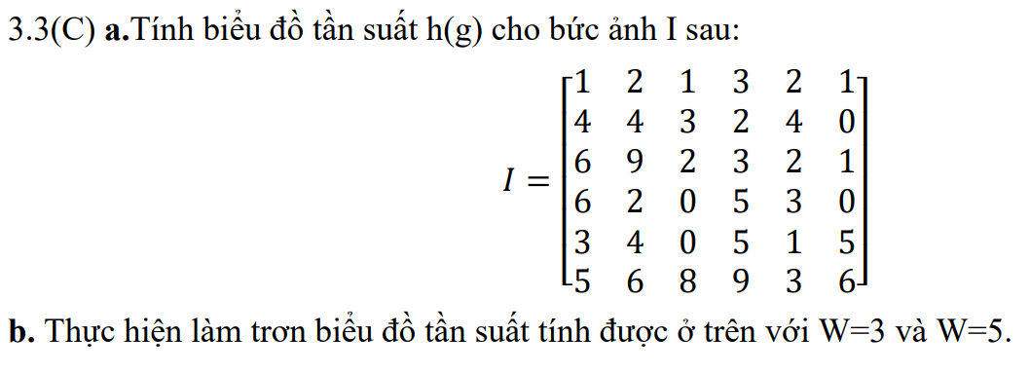

**Giải**

**a/**

|  |  |  |  |  |  |  |  |  |  |  |
| --- | --- | --- | --- | --- | --- | --- | --- | --- | --- | --- |
| g | 0 | 1 | 2 | 3 | 4 | 5 | 6 | 7 | 8 | 9 |
| h(g) | 4 | 5 | 6 | 6 | 4 | 4 | 4 | 0 | 1 | 2 |

**From g – w to g + w**

**b/** Với w=3

+) H’(0) = 1/3 * [h(-1) + h(0) + h(1)] = 1/3 * (0 + 4 + 5) = 3

+) H’(1) = 1/3 * [h(0) + h(1) + h(2)] = 1/3 * (4 + 5 + 6) = 5

+) H’(2) = 1/3 * [h(1) + h(2) + h(3)] = 1/3 * (5 + 6 + 6) = 17/3 = 5.6 = 6

+) H’(3) = 1/3 * [h(2) + h(3) + h(4)] = 1/3 * (6 + 6 + 4) = 16/3 = 5.3 = 5

+) H’(4) = 1/3 * [h(3) + h(4) + h(5)] = 1/3 * (6 + 4 + 4) = 14/3 = 4.6 = 5

+) H’(5) = 1/3 * [h(4) + h(5) + h(6)] = 1/3 * (4 + 4 + 4) = 4

+) H’(6) = 1/3 * [h(5) + h(6) + h(7)] = 1/3 * (4 + 4 + 0) = 8/3 = 2.6 = 3

+) H’(8) = 1/3 * [h(7) + h(8) + h(9)] = 1/3 * (0 + 1 + 2) = 1

+) H’(9) = 1/3 * [h(8) + h(9) + h(10)] = 1/3 * (1 + 2 + 0) = 1

|  |  |  |  |  |  |  |  |  |  |  |
| --- | --- | --- | --- | --- | --- | --- | --- | --- | --- | --- |
| g | 0 | 1 | 2 | 3 | 4 | 5 | 6 | 7 | 8 | 9 |
| H’(g) | 3 | 5 | 6 | 5 | 5 | 4 | 3 | 2 | 1 | 1 |

+) H’(0) = 1/5 * [h(-2) + h(-1) + h(0) + h(1) + h(2)] = 1/5 * (0 + 0 + 4 + 5 + 6) = 3

+) H’(1) = 1/5 * [h(-1) + h(0) + h(1) + h(2) + h(3)] = 1/5 * (0 + 4 + 5 + 6 + 6) = 21/5 = 4.2 = 4

+) H’(2) = 1/5 * [h(0) + h(1) + h(2) + h(3) + h(4)] = 1/5 * (4 + 5 + 6 + 6 + 4) = 5

+) H’(3) = 1/5 * [h(1) + h(2) + h(3) + h(4) + h(5)] = 1/5 * (5 + 6 + 6 + 4 + 4) = 5

+) H’(4) = 1/5 * [h(2) + h(3) + h(4) + h(5) + h(6)] = 1/5 * (6 + 6 + 4 + 4 + 4) = 24/5 = 4.8 = 5

+) H’(5) = 1/5 * [h(3) + h(4) + h(5) + h(6) + h(7)] = 1/5 * (6 + 4 + 4 + 4 + 0) = 18/5 = 3.6 = 4

+) H’(6) = 1/5 * [h(4) + h(5) + h(6) + h(7) + h(8)] = 1/5 * (4 + 4 + 4 + 0 + 1) = 13/5 = 2.6 = 3

+) H’(7) = 1/5 * [h(5) + h(6) + h(7) + h(8) + h(9)] = 1/5 * (4 + 4 + 0 + 1 + 2) = 11/5 = 2.2 = 2

+) H’(8) = 1/5 * [h(6) + h(7) + h(8) + h(9) + h(10)] = 1/5 * (4 + 0 + 1 + 2 + 0) = 7/5 = 1.4 = 1

+) H’(9) = 1/5 * [h(7) + h(8) + h(9) + h(10) + h(11)] = 1/5 * (0 + 1 + 2 + 0 + 0) = 3/5 = 0.6 = 1

Với w = 5

|  |  |  |  |  |  |  |  |  |  |  |
| --- | --- | --- | --- | --- | --- | --- | --- | --- | --- | --- |
| g | 0 | 1 | 2 | 3 | 4 | 5 | 6 | 7 | 8 | 9 |
| H’(g) | 3 | 4 | 5 | 5 | 5 | 4 | 3 | 2 | 1 | 1 |